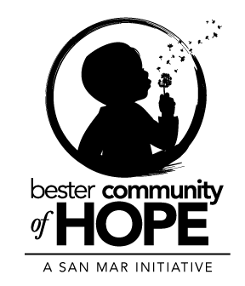
Community Advisory Board
Minutes for December 9th, 2021

Time:

In Attendance: See sign in sheet

Bester Community of Hope – Programs

- Schools: BOOST After School Programming
  - BOOST Programming at Bester Elementary School
    - Cycle 1: 70 students enrolled, 8 students on the waitlist
      - Clubs offered: Slice of Art, Girls on The Run, SPARK, Next Gen Robotics, Artist Hub & Kickball
    - Cycle 2: 73 students enrolled, 10 students on the waitlist
      - Clubs offered: Girls on The Run, SPARK, Musical Gamers, Graphic Masters, Friend-Ship, BOOST GIRLS & Dodge It
    - Cycle 3: 59 students enrolled, 5 students on the waitlist
      - Clubs offered: Board Together, SPARK, Intune, Super Kids, Build It Up!, Bump, Set, Spike & Basketball
    - Service-Learning Project: In Cycle 2 the students in Girls on The Run completed a service-learning project, where they partnered with Julia Manor to create holiday decorations for the halls of the building. The students worked hard to create posters, Christmas tree ornaments and garland.
    - If you are interested in becoming a contractor for the after school program, get in contact with Amanda Boyle.
  - Walking School Bus – meet on Wednesday mornings to walk students to school

- Families:
  - September – November:
    - Total number of referrals: 22 Referrals
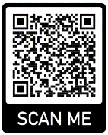
    - Total number of transitions: 14 successful transitions
    - September: 38 families/ 180 individuals
    - October: 35 families/ 160 individuals
    - November: 30 families/ 157 individuals
  - Biggest needs for families identified: Housing, mental health, quality childcare, and substance use/recovery support
  - Virtual Parent Cafes were offered once a month this quarter
    - Upcoming VPC will be January 12th 12-2 PM

- Community:
  - Save the Dates:
    - 6th Annual Babypalooza, Saturday April 2nd, 2022 – 10:00am – 2:00pm at BES
      - Planning meetings occur monthly – Next meeting is January 21st, 9:00 – 10:00am
  - South End Mural
    - Locations identified
    - We have initiated the creative process on two of the four sites
        - 527 S Potomac St (North facing) – Collaboration with CAC
        - 218 E Antietam St (old parking deck) – Collaboration with Meritus Health
        - E Baltimore St and S Locust St – connection still being explored
  - Better Together:
    - October 2021 “Winter is Coming” Coat Drive; we collected around 100 coats throughout the months of September and October and have been supplying the collections to on-going winter giveaway opportunities in the South End. We received a private donation to purchase new coats for families in our community. Our last collected donation will go to the Winter Clothing Giveaway event from Free Clothing Saturdays on December 11th.
    - November 20th- Mulberry St Cleanup; a collaboration between the Bester Community Neighborhood 1st Group and the WCHD Harm Reduction Program – the 200 and 300 block of Mulberry St was cleared from debris and trash and touch-ups were done through Ray and Elm Streets.
    - November 30th- Book-a-thon; residents and stakeholders gathered to process and sort around 500 books and later wrap 300 books to be given away at the December event.
    - December 17th – “Holiday Cheer at the Manor”; resident led initiative in collaboration with HHA, The Hub at USMH, The Judy Center, and The Community Book Warehouse we will host families at the Frederick Manor gym for hot cocoa, cookies, caroling, and books
    - January 13th – Lunch on the go at Crown Hotel (more details will be available at later time)
    - Together Boxes – 4 locations with 10 packets each Friday – Please reach out if you would like to sponsor the 2nd and 4th Friday’s activities
  - Community Connections:
    - Community Coffee continues to be available Thursday mornings from 9:00am to 10:30am, and on third Thursday only in the evening from 6:00pm to 7:30pm. Community Coffee will back in-person starting January 15th in our office – 356 Mill St.
    - “Community Talks” Survey – the purpose of this survey is to collect data primarily from residents regarding the strengths, concerns, and hopes for the South End. If you are a resident or stakeholder in the South End, please scan the QR Code below to access the survey, your feedback is incredibly important and valued. Thank you!
    - Neighborhood Summit – On Thursday January 20th we will host a summit to discuss the data collected from the “Community Talks” surveys. The information gathered will be utilized in the revision of our Logic Model which will provide the goals for our community work for the next three (3) years.
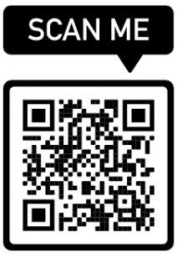
Open Discussion/Community Updates
- Lea Anne Chin-Loy, Parent Partner Program with Maryland Coalition of Families
  - Work with families that have DSS involvement – wide variety of supports
- Chris Cassatt – Free Clothing Saturday this Saturday the 11th – Christmas goodies!
  - @ 501 W. Memorial Blvd
- Jane – Program Coordinator for Literacy Program of Washington County
  - Looking to host ESL English Conversation Classes
  - Can help with a plethora of skills – reading, math, finances, GED
  - Seeking out students and tutors
- Kim Halsey – Pantry on the Go this Saturday the 11th at St. John’s Episcopal in back parking lot
- Sandra Balbuena – HUB @ USMH hosting playgroups at Discovery Station on Mondays from 1-2

This Saturday
10-1 Free Clothing Saturday
2nd exit on Roundabout – Pantry on the Go at St. John’s Episcopal
Go up to Antietam and down Potomac – Cold Harms Warm Hearts with It’s a Blessing
5pm – Church of the Brethren To-Go Christmas Dinner

